5 Practical Prompt for Class Demonstration

Prompt 1: Recruitment Campaign
“Create a professional hiring poster for a company recruiting Data Analysts. Include modern office background, diverse team, and text ‘Join Our Team’ with a corporate style.
CHATGPT:

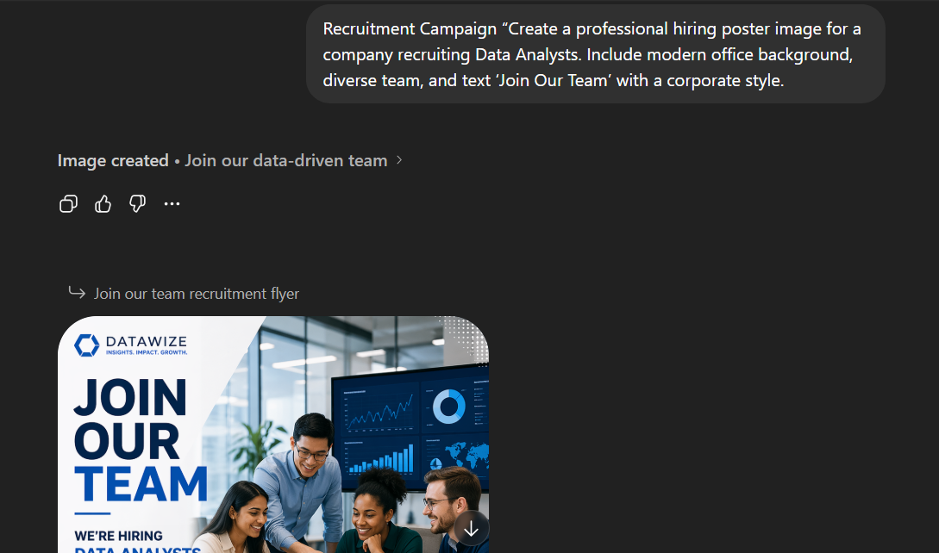

Prompt 2: Employer Branding
“Generate an image showing a happy corporate workplace with employees collaborating, representing a positive work culture, suitable for LinkedIn employer branding.”
Genspark:

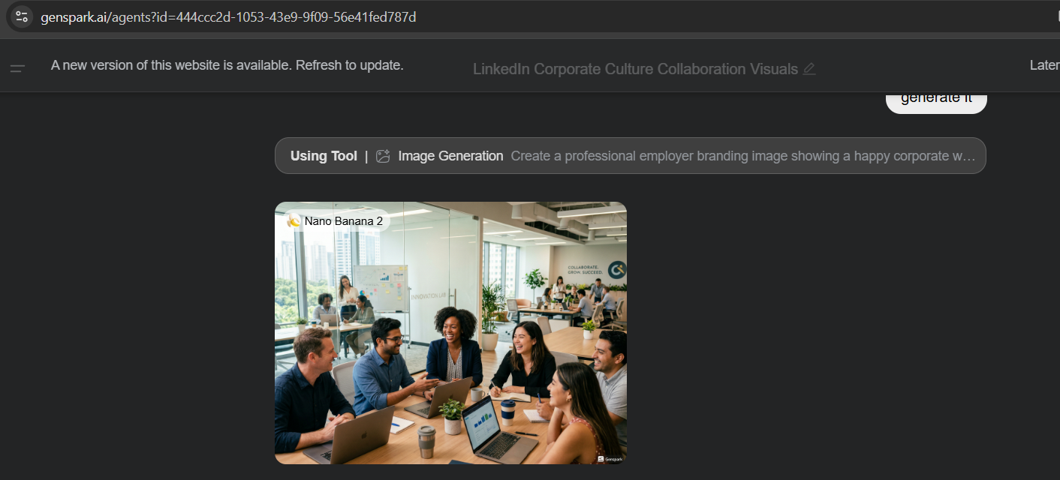

Prompt 3: Work From Home Policy
“Create a clean and professional illustration showing employees working remotely from home, suitable for announcing a work-from-home policy.”
Flowith:

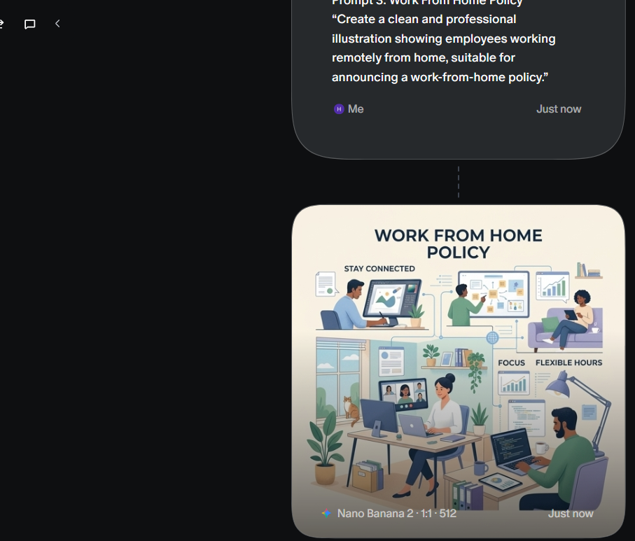

Prompt 4: Employee Engagement Activity
“Design a creative poster for an employee engagement event titled ‘Team Building Day’, with vibrant colours and corporate theme.”
Gemini:

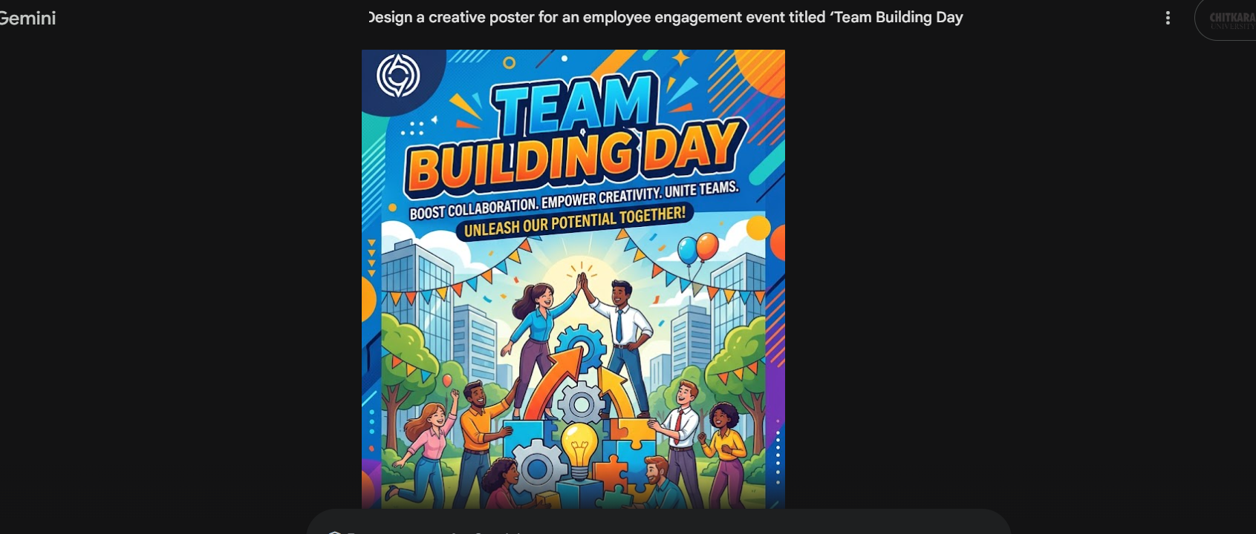

Prompt 5: Diversity and Inclusion Campaign
“Generate an image representing workplace diversity and inclusion with people of different backgrounds working together in a corporate environment.”
Grok:

